A CASE-STUDY BASED REPORT
ON
Crop Recommendation Using Multinomial Logistic Regression
submitted in partial fulfilment of the requirements for the Course
MACHINE LEARNING
BACHELOR OF TECHNOLOGY
in
COMPUTER SCIENCE & INFORMATION TECHNOLOGY
A.Y.: 2026-27
by
Name: CH. Sai Vihamsh | Roll: 2520090090
Name: S. Pardhu Saradhi  Name: I.Vikram | Roll: 2520090043  Roll:2520090118
Under the Esteemed guidance of
Dr. Y. Lakshmi Prasanna
Asst. Professor, Dept. of CS&IT



INDEX
Abstract
Introduction
Background
Motivation for the Project
Overview of the Work Carried Out
Scope and Responsible-Use Statement
Software and Hardware Requirements
Problem Statement
Case-Study Scenario
Central Case-Study Question
Formal Problem Definition
Objectives that Guide the Study
Assumptions and Limitations
Dataset and Exploratory Data Analysis
About the Dataset
Purpose of EDA
Preparation Steps Actually Performed
EDA Exploration - Implementation
Summary of EDA Findings
Algorithm Selection and Implementation
Why Multinomial Logistic Regression
Mathematical Formulation
Overall Workflow
Implementation
Hyperparameter Tuning
Evaluation Metrics
Results and Discussion
Sample Prediction
Conclusion
References

1. ABSTRACT
Agriculture plays a vital role in the economy and food security of a country, and selecting a suitable crop for cultivation is one of the most important decisions made by farmers. Traditional crop selection often depends on experience, local practices and weather conditions, which may not always give accurate recommendations. This project, “Crop Recommendation Using Multinomial Logistic Regression”, develops a machine learning-based system that recommends the most suitable crop from important soil and environmental parameters.
The system uses Multinomial Logistic Regression, a supervised classification algorithm that predicts one class out of several possible classes. The model takes seven inputs: nitrogen (N), phosphorus (P), potassium (K), temperature, humidity, soil pH and rainfall. The work covers data inspection, exploratory data analysis, feature standardisation, a stratified 80/20 train-test split, hyperparameter tuning of the regularisation strength by 5-fold cross-validation, and evaluation using accuracy, precision, recall, F1-score and a confusion matrix.
On a dataset of 2,200 records covering 22 crops, the tuned model reached a test accuracy of 98.41% (only 7 of 440 test samples misclassified) and a 5-fold cross-validated accuracy of 98.32%. The results show that a simple and interpretable linear model can give fast and reliable crop recommendations, and can serve as a basic decision-support tool for farmers, students, researchers and other agricultural users.

2. INTRODUCTION

2.1 Background
Crop selection is an important part of successful agricultural production. Different crops need different soil nutrients, temperature, humidity, rainfall and pH conditions for healthy growth. Choosing an unsuitable crop can reduce productivity and cause financial loss. A system that can analyse the growing conditions and recommend an appropriate crop can therefore improve decision-making.
Machine learning provides techniques for analysing agricultural data and finding patterns that are not easy to see with traditional methods. In this project, Multinomial Logistic Regression is used as a classification algorithm to predict the most suitable crop from 22 crop categories.

2.2 Motivation for the Project
Many farmers still choose crops from experience or from what neighbouring farms are growing. This can ignore the actual nutrient level and weather conditions of the field and may lead to poor yield, wasted fertiliser and financial loss. A data-driven recommendation that considers soil nutrients and climate together can make this decision more systematic. Logistic regression was chosen because it is fast to train, needs little computing power and gives class probabilities, which makes the recommendation easy to explain to non-technical users.

2.3 Overview of the Work Carried Out
The work carried out in this project consists of the following stages:
- Collection of the crop recommendation dataset in CSV format and loading it with Pandas.
- Data inspection: checking shape, data types, missing values, duplicate records and class balance.
- Exploratory data analysis: feature distributions, correlation heatmap, per-crop box plots and outlier counts.
- Preprocessing: standardising the numerical features and splitting the data into stratified training (80%) and testing (20%) sets.
- Training a Multinomial Logistic Regression model and tuning its regularisation parameter C with 5-fold cross-validation.
- Evaluating the model using accuracy, precision, recall, F1-score, confusion matrix and cross-validation.
- Using the trained model to recommend a crop for new soil and weather inputs.

2.4 Scope and Responsible-Use Statement
The scope of this project is single-label crop recommendation from seven soil and weather parameters. The system is intended as a decision-support tool and not as a replacement for the advice of agricultural experts. The dataset is a curated benchmark and does not include factors such as soil type, season, location, irrigation facilities, market price or pest risk, so a recommendation should be checked against local conditions before any decision is taken. The data used contains no personal information.

2.5 Software and Hardware Requirements
Item | Requirement
Programming language | Python 3.x
IDE / environment | Visual Studio Code, Jupyter Notebook or Google Colab
Libraries | NumPy, Pandas, Scikit-learn, Matplotlib, Seaborn
Dataset format | CSV file (crop_recommendation.csv)
Operating system | Windows 10/11, Linux or macOS
Processor | Intel Core i5 or above
Memory | 8 GB RAM (minimum)
Storage | 10 GB free storage

3. PROBLEM STATEMENT

3.1 Case-Study Scenario
A group of farmers in a region has to decide which crop to grow in the coming season. Each farmer has a soil test report showing nitrogen, phosphorus, potassium and pH values, along with the temperature, humidity and rainfall expected in the area. At present the decision depends on personal experience and local practice, which often ignores how these factors work together. An agricultural advisory service wants a simple system that reads these seven values and suggests the most suitable crop, so that farmers can make quicker and better-informed decisions.

3.2 Central Case-Study Question
Can a Multinomial Logistic Regression model, trained on soil nutrient and climate parameters, correctly recommend the most suitable crop out of 22 possible crops with high accuracy?

3.3 Formal Problem Definition
Given an input vector x = (N, P, K, temperature, humidity, pH, rainfall) and a set of K = 22 crop classes, the task is to learn a function f that maps x to the most suitable crop:
ŷ = argmax over k of P(y = k | x), k = 1, 2, …, 22
where the class probabilities are given by the softmax function applied to a linear score for each class. The objective is to maximise classification performance, measured by accuracy, precision, recall and F1-score on unseen data.

3.4 Objectives that Guide the Study
- To load, inspect and clean the crop recommendation dataset.
- To explore the data and understand how soil and climate parameters differ across crops.
- To standardise the features and split the data into training and testing sets.
- To build a Multinomial Logistic Regression model for 22-class crop prediction.
- To tune the regularisation strength using cross-validation.
- To evaluate the model using accuracy, precision, recall, F1-score and a confusion matrix.
- To demonstrate crop recommendation for a new set of input values.

3.5 Assumptions and Limitations
- The relationship between the input parameters and the suitable crop is assumed to be reasonably captured by linear decision boundaries after standardisation.
- The dataset is assumed to be representative of the conditions in which the recommendations will be used.
- The dataset has equal samples for each crop (100 each) and no missing values, which is cleaner than real field data.
- Each record gives one value for temperature, humidity and rainfall, so seasonal variation within a year is not modelled.
- Factors such as soil type, location, irrigation, market price and pest risk are not included.
- A linear model cannot capture complex non-linear interactions; crops with overlapping conditions may be confused.

4. DATASET AND EXPLORATORY DATA ANALYSIS

4.1 About the Dataset
The project uses the publicly available Crop Recommendation dataset stored as a CSV file and loaded with Pandas. It contains 2,200 records and 8 columns. Each record gives the soil and weather conditions for one sample together with the crop that suits those conditions. There are 22 crops, with exactly 100 records per crop, so the classes are perfectly balanced. The 22 crops are: rice, maize, chickpea, kidney beans, pigeon peas, moth beans, mung bean, black gram, lentil, pomegranate, banana, mango, grapes, watermelon, muskmelon, apple, orange, papaya, coconut, cotton, jute and coffee.
Feature | Description | Type | Range (mean)
N | Nitrogen content ratio in soil | Numeric | 0 – 140 (50.55)
P | Phosphorus content ratio in soil | Numeric | 5 – 145 (53.36)
K | Potassium content ratio in soil | Numeric | 5 – 205 (48.15)
temperature | Temperature in °C | Numeric | 8.83 – 43.68 (25.62)
humidity | Relative humidity in % | Numeric | 14.26 – 99.98 (71.48)
ph | pH value of the soil | Numeric | 3.50 – 9.94 (6.47)
rainfall | Rainfall in mm | Numeric | 20.21 – 298.56 (103.46)
label (target) | Recommended crop (22 classes) | Categorical | 22 classes × 100 records
Table 4.1: Dataset attributes and their ranges

4.2 Purpose of EDA
Exploratory Data Analysis (EDA) is carried out to understand the structure and quality of the data before modelling. It helps to identify missing values, outliers, class balance, the spread of each feature and the relationships between features, and it shows how well the crops can be told apart from the inputs. These observations guide the choice of preprocessing and of the model.

4.3 Preparation Steps Actually Performed
- Data loading: the CSV file was loaded and its shape (2200 × 8), data types and summary statistics were inspected.
- Missing values and duplicates: the dataset has 0 missing values and 0 duplicate rows, so no imputation or removal was required.
- Class balance: all 22 crops have exactly 100 records, so no resampling was needed.
- Outlier check: outliers were counted using the 1.5 × IQR rule (Table 4.2). They were retained because they are genuine growing conditions of particular crops and not recording errors.
- Standardisation: all seven features were scaled to zero mean and unit variance using StandardScaler, because logistic regression with regularisation is sensitive to feature scale. The scaler is fitted only on the training data inside a Pipeline to avoid data leakage.
- Train-test split: a stratified 80/20 split (random_state = 42) gave 1760 training and 440 testing records, with every crop represented equally in both parts.

Feature | N | P | K | Temp. | Humidity | pH | Rainfall
IQR outliers | 0 | 138 | 200 | 86 | 30 | 57 | 100
Table 4.2: Number of IQR outliers per feature (out of 2200 records)

4.4 EDA Exploration - Implementation
The following Python code (Pandas, NumPy, Matplotlib, Seaborn) was used for the EDA:
import pandas as pd, numpy as np
import matplotlib.pyplot as plt, seaborn as sns

df = pd.read_csv('crop_recommendation.csv')
features = ['N','P','K','temperature','humidity','ph','rainfall']

print(df.shape); df.info()
print(df.isnull().sum()); print(df.duplicated().sum())
print(df.describe())
print(df['label'].value_counts())

# Class distribution
df['label'].value_counts().plot(kind='bar'); plt.show()
# Feature distributions
df[features].hist(bins=30, figsize=(14,7)); plt.show()
# Feature values by crop
sns.boxplot(data=df, y='label', x='rainfall'); plt.show()
# Correlation heatmap
sns.heatmap(df[features].corr(), annot=True, fmt='.2f', cmap='RdYlGn', center=0)
plt.show()

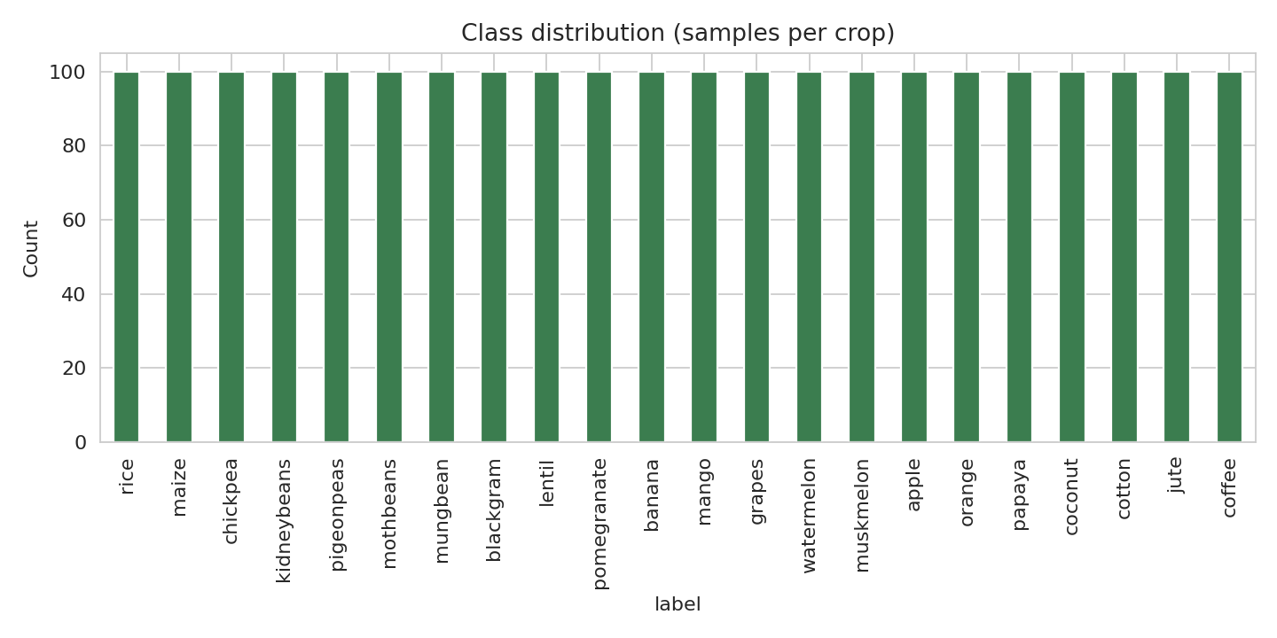
Figure 4.1: Number of samples per crop (all 22 classes have 100 records)
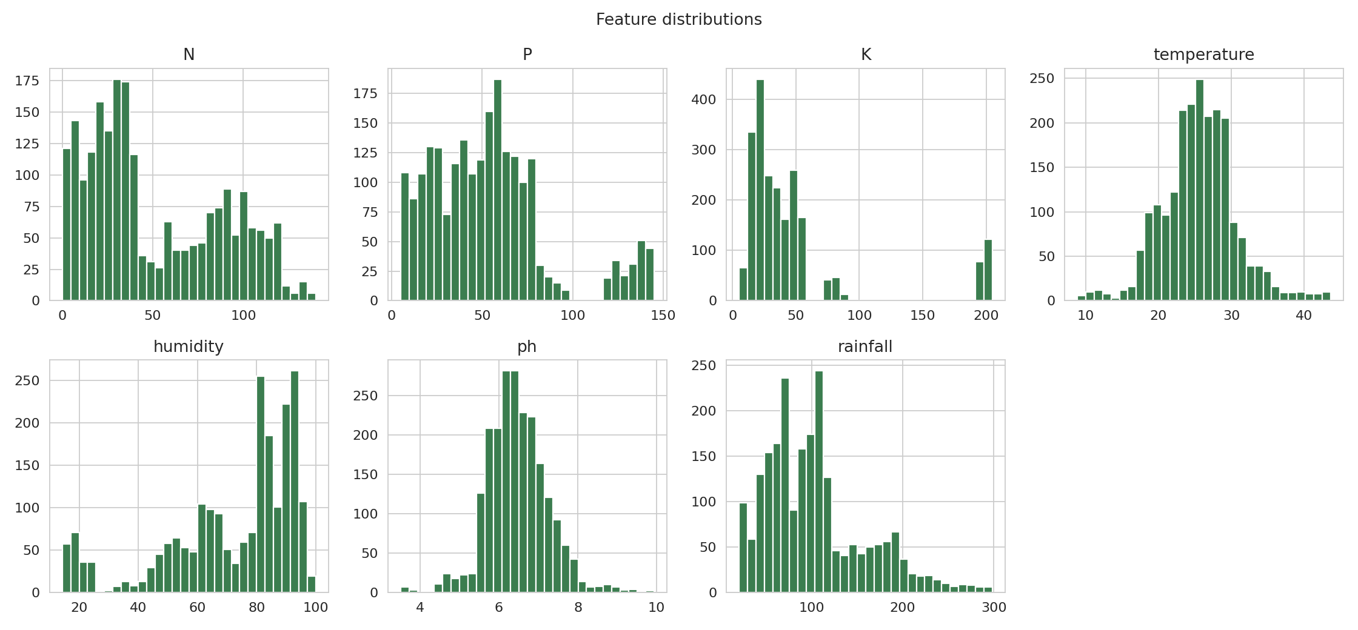
Figure 4.2: Distribution of the seven input features
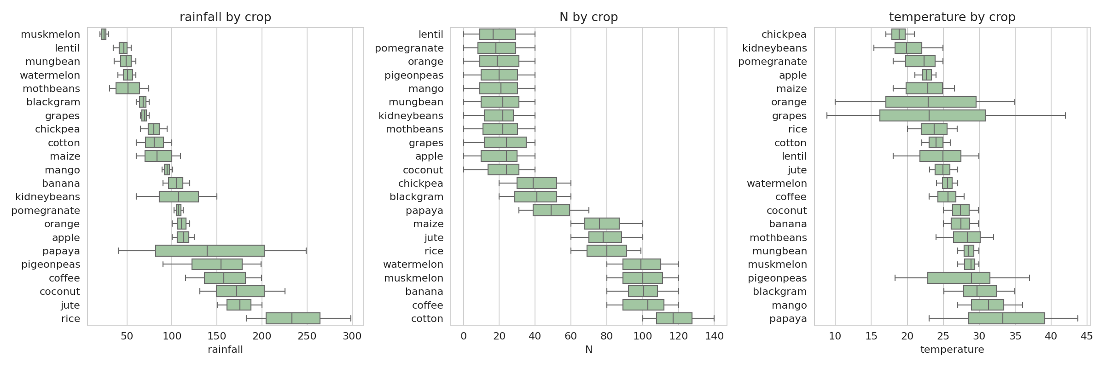
Figure 4.3: Rainfall, nitrogen and temperature across crops
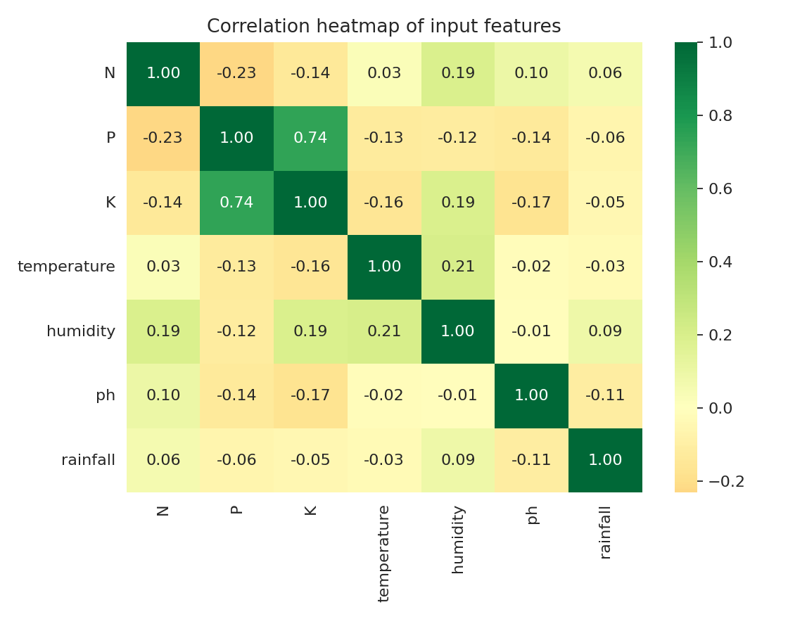
Figure 4.4: Correlation heatmap of the input features

4.5 Summary of EDA Findings
- The dataset is clean and balanced: 2,200 records, no missing values, no duplicates and exactly 100 records for each of the 22 crops.
- The crops have clearly different growing conditions. Rice, coconut and jute grow at high rainfall (mean about 236 mm, 176 mm and 175 mm), while muskmelon, lentil and mung bean need far less (about 25 mm, 46 mm and 48 mm).
- Potassium is very high only for grapes and apple (mean about 200), which explains the 200 potassium outliers. Humidity is highest for coconut, papaya and muskmelon (above 92%) and lowest for chickpea and kidney beans (below 22%).
- Most features are weakly correlated with each other. The only strong relationship is between phosphorus and potassium (r = 0.74); the other correlations are below 0.25 in magnitude. Since logistic regression is applied with regularisation, this moderate collinearity is acceptable.
- Individual features overlap between crops, but the combination of the seven features separates the crops well, which supports the use of a multi-class classifier.
- Outliers reflect real crop-specific conditions rather than errors, so they were kept in the data.

5. ALGORITHM SELECTION AND IMPLEMENTATION

5.1 Why Multinomial Logistic Regression
Crop recommendation is a multi-class classification problem with 22 possible outputs. Multinomial Logistic Regression (also called softmax regression) extends binary logistic regression to more than two classes by learning one set of weights for every class and predicting all class probabilities together in a single model. It was selected because:
- it handles many classes directly, without training separate one-vs-rest models;
- it outputs a probability for every crop, so the confidence of a recommendation can be shown to the user;
- it is fast to train and needs very little computing power;
- its coefficients are easy to interpret, which suits a decision-support tool.

5.2 Mathematical Formulation
For an input vector x, the model computes a linear score for each class k and converts the scores into probabilities using the softmax function:
z_k = w_k · x + b_k
P(y = k | x) = exp(z_k) / Σ_j exp(z_j), j = 1 … 22
The weights are learned by minimising the cross-entropy (log) loss with L2 regularisation. The parameter C is the inverse of the regularisation strength: a small C applies strong regularisation, and a large C lets the model fit the training data more closely. The predicted crop is the class with the highest probability. In scikit-learn, the lbfgs solver fits this single softmax (multinomial) model when the target has more than two classes.

5.3 Overall Workflow
Crop dataset (CSV) → Data inspection → EDA → Standardisation → Stratified train-test split → Train Multinomial Logistic Regression → Tune C with 5-fold cross-validation → Evaluate on test set (accuracy, precision, recall, F1, confusion matrix) → Crop recommendation

5.4 Implementation
from sklearn.model_selection import (train_test_split, GridSearchCV,
StratifiedKFold)
from sklearn.preprocessing import StandardScaler
from sklearn.linear_model import LogisticRegression
from sklearn.pipeline import Pipeline
from sklearn.metrics import (accuracy_score, classification_report,
confusion_matrix)

X = df[features]; y = df['label']
X_train, X_test, y_train, y_test = train_test_split(
X, y, test_size=0.2, stratify=y, random_state=42)

# Scaling + multinomial (softmax) logistic regression in one pipeline
pipe = Pipeline([('scaler', StandardScaler()),
('lr', LogisticRegression(solver='lbfgs', max_iter=2000))])

# Tune C with 5-fold stratified cross-validation (training data only)
grid = GridSearchCV(pipe, {'lr__C': [0.01, 0.1, 1, 10, 100, 1000]},
cv=StratifiedKFold(5, shuffle=True, random_state=42),
scoring='accuracy')
grid.fit(X_train, y_train)
model = grid.best_estimator_

# Evaluation on the unseen test set
y_pred = model.predict(X_test)
print(accuracy_score(y_test, y_pred))
print(classification_report(y_test, y_pred))
cm = confusion_matrix(y_test, y_pred)

# Recommending a crop for new input
new = pd.DataFrame([[90, 42, 43, 20.9, 82.0, 6.5, 203.0]], columns=features)
print(model.predict(new), model.predict_proba(new).max())

5.5 Hyperparameter Tuning
The regularisation parameter C was tuned on the training set only, using stratified 5-fold cross-validation, so the test set stayed unseen until the final evaluation. Very strong regularisation (C = 0.01) underfits the data, and accuracy rises quickly up to C = 10 and then levels off. The best cross-validated accuracy of 97.78% was obtained at C = 100.
C | Mean 5-fold CV accuracy (%)
0.01 | 79.09
0.1 | 93.18
1 | 96.82
10 | 97.73
100 | 97.78
1000 | 97.67
Table 5.1: Cross-validation accuracy for different values of C (best value highlighted)
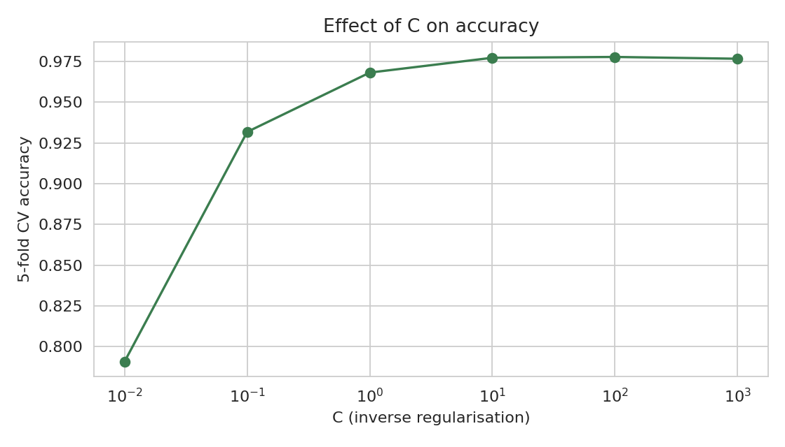
Figure 5.1: Effect of the regularisation parameter C on cross-validated accuracy

5.6 Evaluation Metrics
Crop recommendation is a classification task, so the following metrics are used:
- Accuracy = (number of correct predictions) / (total predictions).
- Precision = TP / (TP + FP) – of the samples predicted as a crop, how many truly belong to it.
- Recall = TP / (TP + FN) – of the samples of a crop, how many were found.
- F1-score = 2 × (Precision × Recall) / (Precision + Recall) – the harmonic mean of precision and recall.
- Confusion matrix – shows for every actual crop which crop the model predicted, so the specific mistakes can be seen.
Precision, recall and F1-score are calculated for each crop and then averaged. Because all classes have the same number of test samples, the weighted and macro averages are equal.

5.7 Results and Discussion
Metric (test set, 440 samples) | Value
Accuracy | 98.41%
Precision (weighted) | 98.52%
Recall (weighted) | 98.41%
F1-score (weighted) | 98.40%
Training accuracy | 99.03%
5-fold CV accuracy on full data (mean ± std) | 98.32% ± 0.18%
Table 5.2: Performance of the tuned Multinomial Logistic Regression model
Model setting | Test accuracy
Default setting (C = 1) | 97.27%
Tuned setting (C = 100) | 98.41%
Table 5.3: Effect of tuning on test accuracy
The tuned model correctly classified 433 of the 440 test samples. The training accuracy (99.03%) and test accuracy (98.41%) are close to each other, and the five cross-validation folds all lie between 98.18% and 98.64%, so the model is stable and does not show signs of serious overfitting. Tuning C improved test accuracy over the default setting by about 1.1 percentage points.
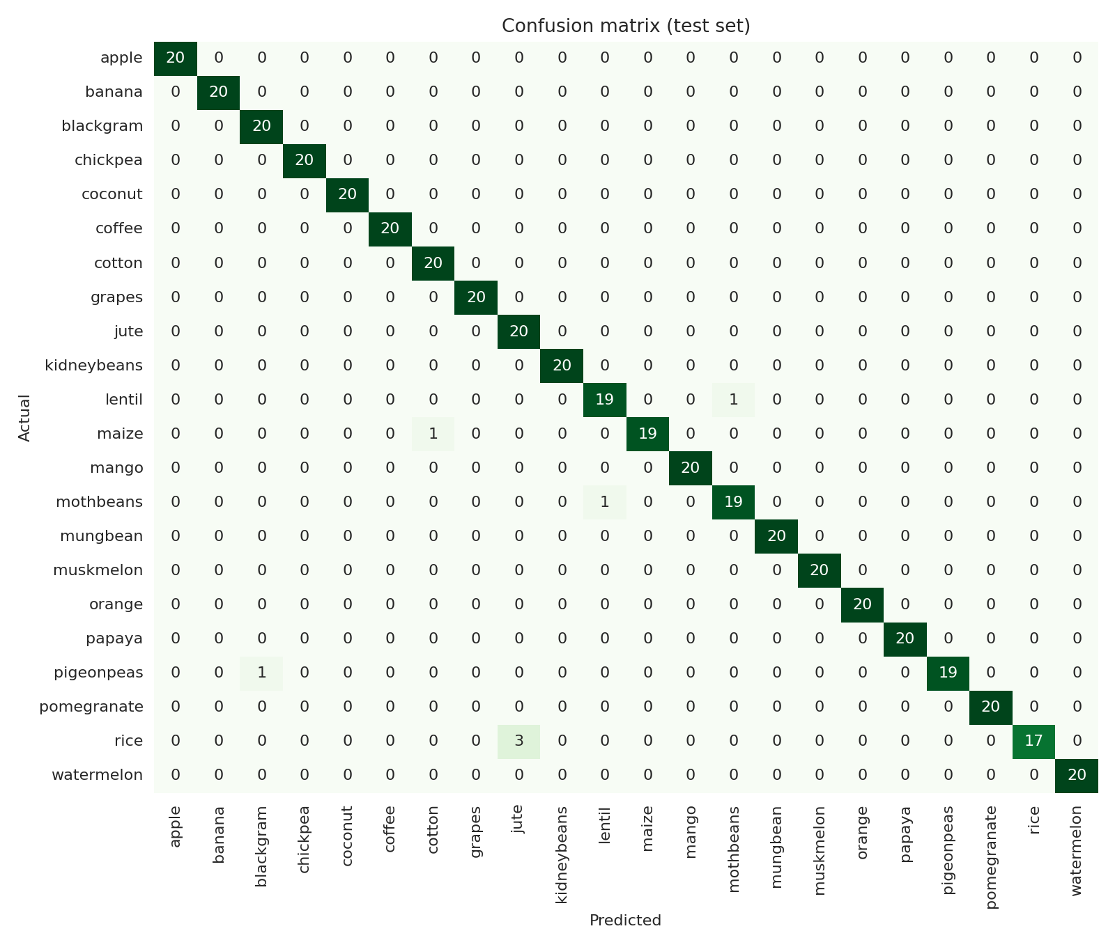
Figure 5.2: Confusion matrix of the model on the test set
The confusion matrix shows that 17 of the 22 crops were recognised perfectly (all 20 test samples correct). The seven mistakes occurred between crops with similar growing conditions:
- rice was predicted as jute three times (both crops grow at high rainfall and high humidity), and this is the weakest class with an F1-score of 0.92;
- lentil and moth beans were confused with each other once each;
- one pigeon peas sample was predicted as black gram, and one maize sample as cotton.
The standardised coefficients show how strongly each feature separates the crops. Averaged over all classes, humidity (7.37), phosphorus (6.15), potassium (6.07), rainfall (5.91) and nitrogen (5.43) have the largest influence, while temperature (1.93) and pH (0.86) have a smaller influence. This does not mean that pH is unimportant in agriculture; it only shows that, in this dataset, pH alone separates the crops less than the other features.
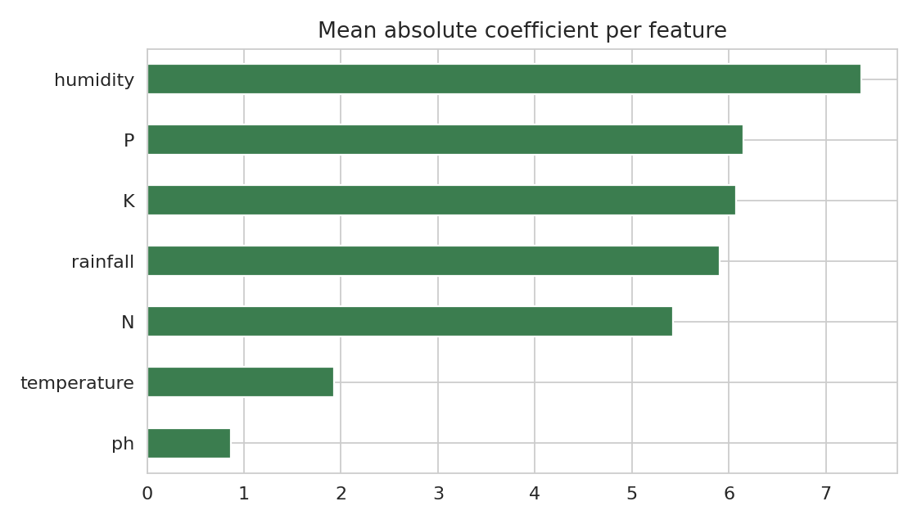
Figure 5.3: Average absolute standardised coefficient of each feature

5.8 Sample Prediction
To demonstrate the system, the soil and weather values N = 90, P = 42, K = 43, temperature = 20.9 °C, humidity = 82.0%, pH = 6.5 and rainfall = 203.0 mm were given to the trained model. The model recommended rice with a probability of 92.7%, with jute as the second choice (7.3%). Showing the probabilities along with the recommendation lets the user see how confident the model is.

6. CONCLUSION
This project developed a crop recommendation system using Multinomial Logistic Regression. The model uses seven soil and weather parameters (N, P, K, temperature, humidity, pH and rainfall) to choose one of 22 crops. After standardising the features and tuning the regularisation parameter by cross-validation, the model reached 98.41% accuracy on unseen test data, with precision, recall and F1-score of about 98.4–98.5%, and a 5-fold cross-validated accuracy of 98.32%. The few errors were between crops with similar rainfall, humidity and nutrient needs, such as rice and jute.
The results answer the case-study question: a simple, fast and interpretable linear model can recommend crops with high accuracy on this dataset, and it also gives a probability for each recommendation. The project shows a practical application of machine learning in agriculture and can serve as a basic decision-support tool for farmers, students and researchers.
Since the dataset is clean, balanced and curated, the accuracy on real field data may be lower. Future work may include collecting real field data with soil type, season and location, comparing the model with Random Forest, SVM, XGBoost or neural networks, adding market price and yield information, and deploying the model as a web or mobile application for farmers.

Signature of the Team members | Signature of the Guide / Course Instructor

REFERENCES
[1] Crop Recommendation Dataset, Kaggle (publicly available dataset of soil nutrients, climate parameters and recommended crops).
[2] Pedregosa, F. et al., “Scikit-learn: Machine Learning in Python”, Journal of Machine Learning Research, vol. 12, pp. 2825–2830, 2011.
[3] Hosmer, D. W., Lemeshow, S. and Sturdivant, R. X., Applied Logistic Regression, 3rd ed., Wiley, 2013.
[4] Scikit-learn documentation: LogisticRegression, StandardScaler, GridSearchCV and classification metrics, https://scikit-learn.org.

